Semester One Examination, 2018

Question/Answer booklet

MATHEMATICS SPECIALIST
UNIT 3

Section One:

Calculator-free

Marking Key

Time allowed for this section
Reading time before commencing work: five minutes
Working time: fifty minutes

Materials required/recommended for this section
To be provided by the supervisor
This Question/Answer booklet
Formula sheet

To be provided by the candidate
Standard items: pens (blue/black preferred), pencils (including coloured), sharpener, correction fluid/tape, eraser, ruler, highlighters

Special items: nil

Important note to candidates
No other items may be taken into the examination room. It is your responsibility to ensure that you do not have any unauthorised material. If you have any unauthorised material with you, hand it to the supervisor before reading any further.

Question | Mark | Question | Mark
1 |  | 5
2 |  | 6
3 |  | 7
4 |  | 8

Structure of this paper

Section | Number of questions available | Number of questions to be answered | Working time (minutes) | Marks available | Percentage of examination
Section One:  Calculator-free | 8 | 8 | 50 | 50 | 35
Section Two:  Calculator-assumed | 13 | 13 | 100 | 95 | 65
 |  |  |  | Total | 100

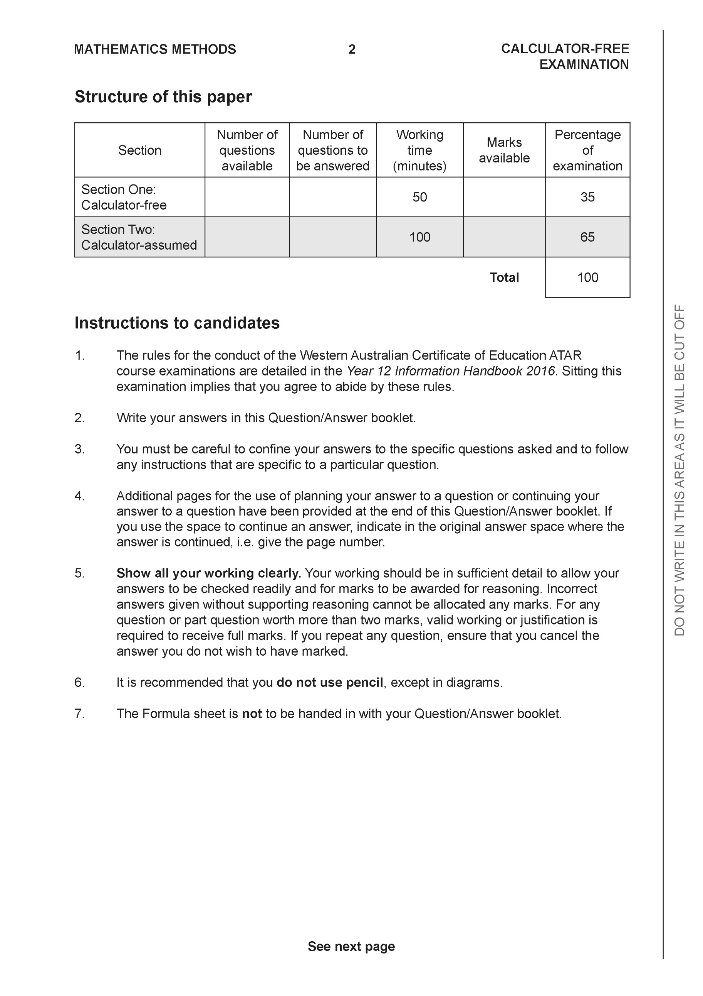

Section One: Calculator-free (50 Marks)

This section has eight (8) questions. Answer all questions. Write your answers in the spaces provided.

Spare pages are included at the end of this booklet. They can be used for planning your responses and/or as additional space if required to continue an answer.
● Planning: If you use the spare pages for planning, indicate this clearly at the top of the page.
● Continuing an answer: If you need to use the space to continue an answer, indicate in the original answer space where the answer is continued, i.e. give the page number. Fill in the number of the question that you are continuing to answer at the top of the page.

Working time: 50 minutes.

Question 1 (8 marks)

Consider the polynomial where
(a) Determine the roots of and label them (2 marks)

Solution
Specific behaviours
uses quadratic formula
obtains two complex roots

(b) Determine (3 marks)

Solution
Specific behaviours
uses conjugates correctly
multiplies correctly
obtains simplified sum

(c) Determine (3 marks)

Solution
Specific behaviours
expands expression in terms of variables
separates sums that give zero
obtains simplified real result

Question 2 (7 marks)

Let where are real numbers.
(a) Show that (2 marks)

Solution
Specific behaviours
obtains expression for modulus of w
raises modulus to power of 6

(b) The expression can be written in the form , determine expressions for the real constants in terms of . (3 marks)

Solution
Specific behaviours
uses conjugate to obtain real denominator
changes both terms to have the same denominator
obtains final expressions for c & d

(c) Given that the and , determine the . (2 marks)
Solution
Specific behaviours
multiplies Arg(w) by 6
obtains expression for Arg(w) in terms of pi

Question 3 (7 marks)

Consider the following functions .

(a) State the natural domain and range of . (2 marks)

Solution

Domain

Range

Specific behaviours
states domain
states range

(b) State the natural domain and range of (3 marks)

Solution
Specific behaviours
uses domain of f(x)
uses rule to find range
states range

(c) Does exist over the natural domain of ? Explain. (2 marks)

Solution
Specific behaviours
states condition for existence
states relevant domain and ranges

Question 4 (7 marks)

Consider the function , which is plotted on the axes below.

(a) Sketch the inverse function on the axes above. (3 marks)

Solution
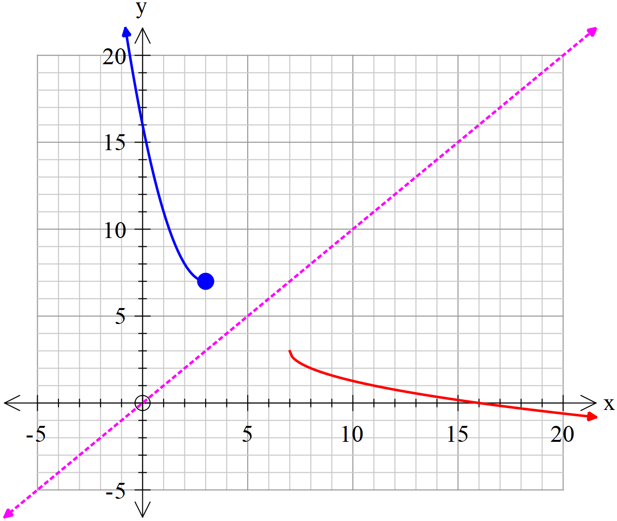

Specific behaviours
vertex of (7,3) plotted
reflected in line y=x
x intercept of (16,0) plotted

(b) Determine the rule for the inverse function and state the domain and range.
(4 marks)

Solution
Specific behaviours
interchanges x and y
completes the square or uses quadratic formula
obtains expression for inverse with minus sign
states domain and range of inverse

Question 5 (5 marks)

Consider the graph of which is graphed below.
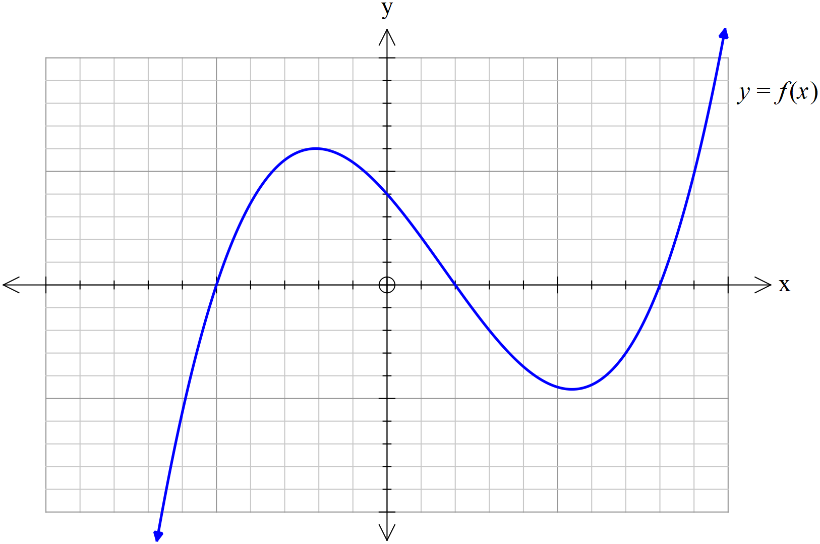

(a) On the axes below, sketch (2 marks)
Solution

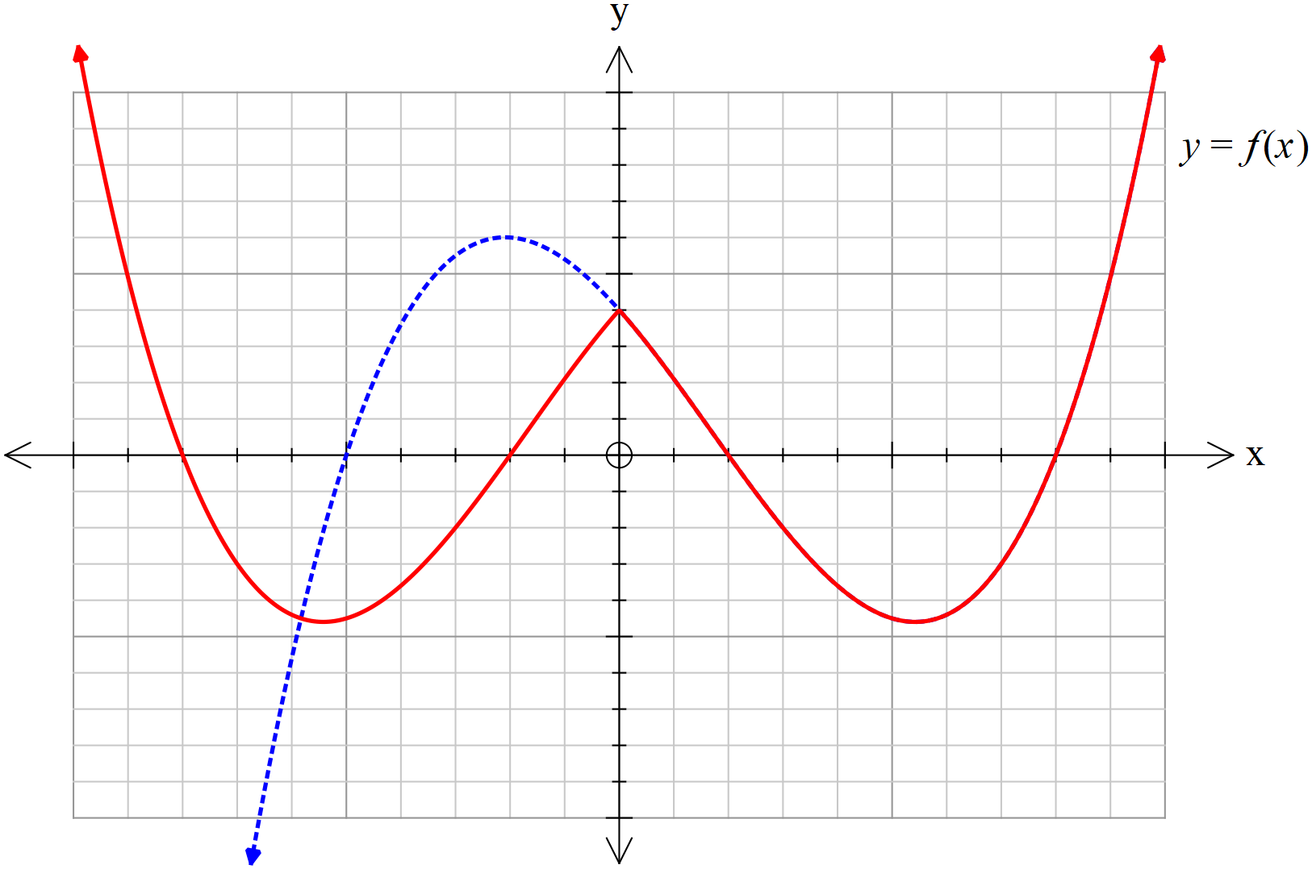

Specific behaviours
right side reflected in y axis
correct x , y intercepts and turning point on LHS

(b) On the axes below, sketch (3 marks)
Solution
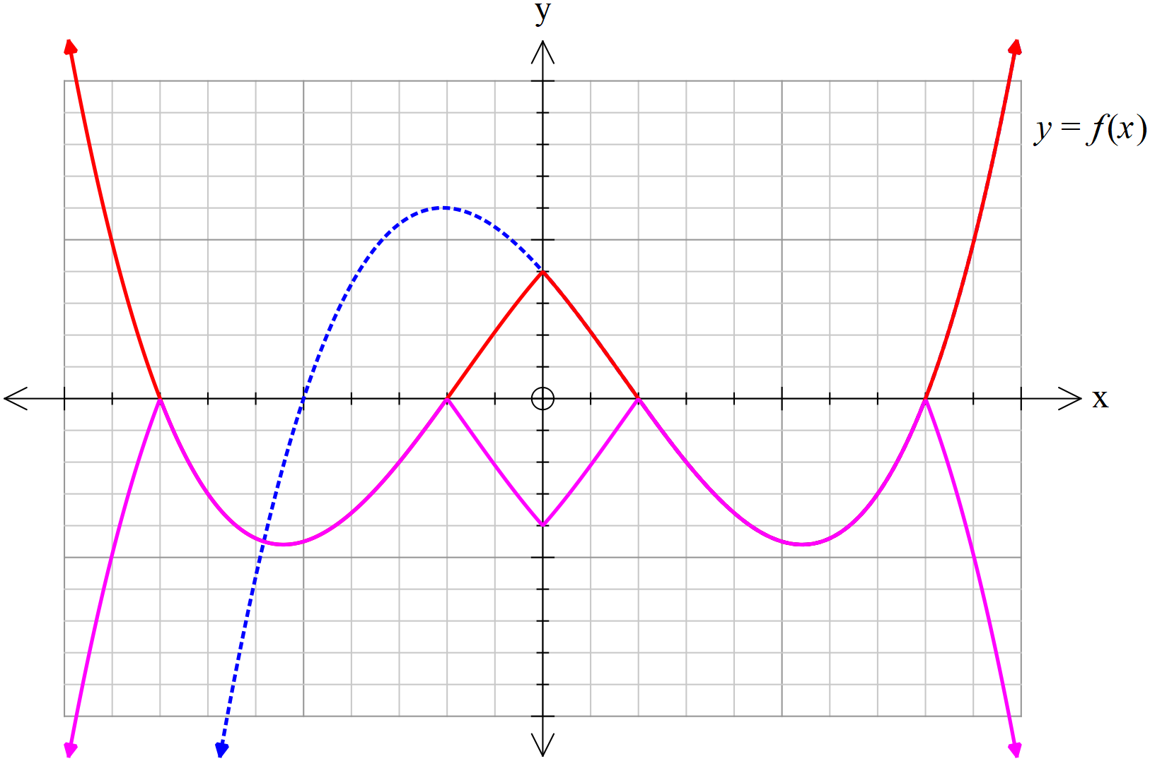

Specific behaviours
lateral symmetry
only plotted on and below x axis
correct x, y intercepts and turning points

Question 6 (6 marks)
Sketch the graph of on the axes below.
Solution
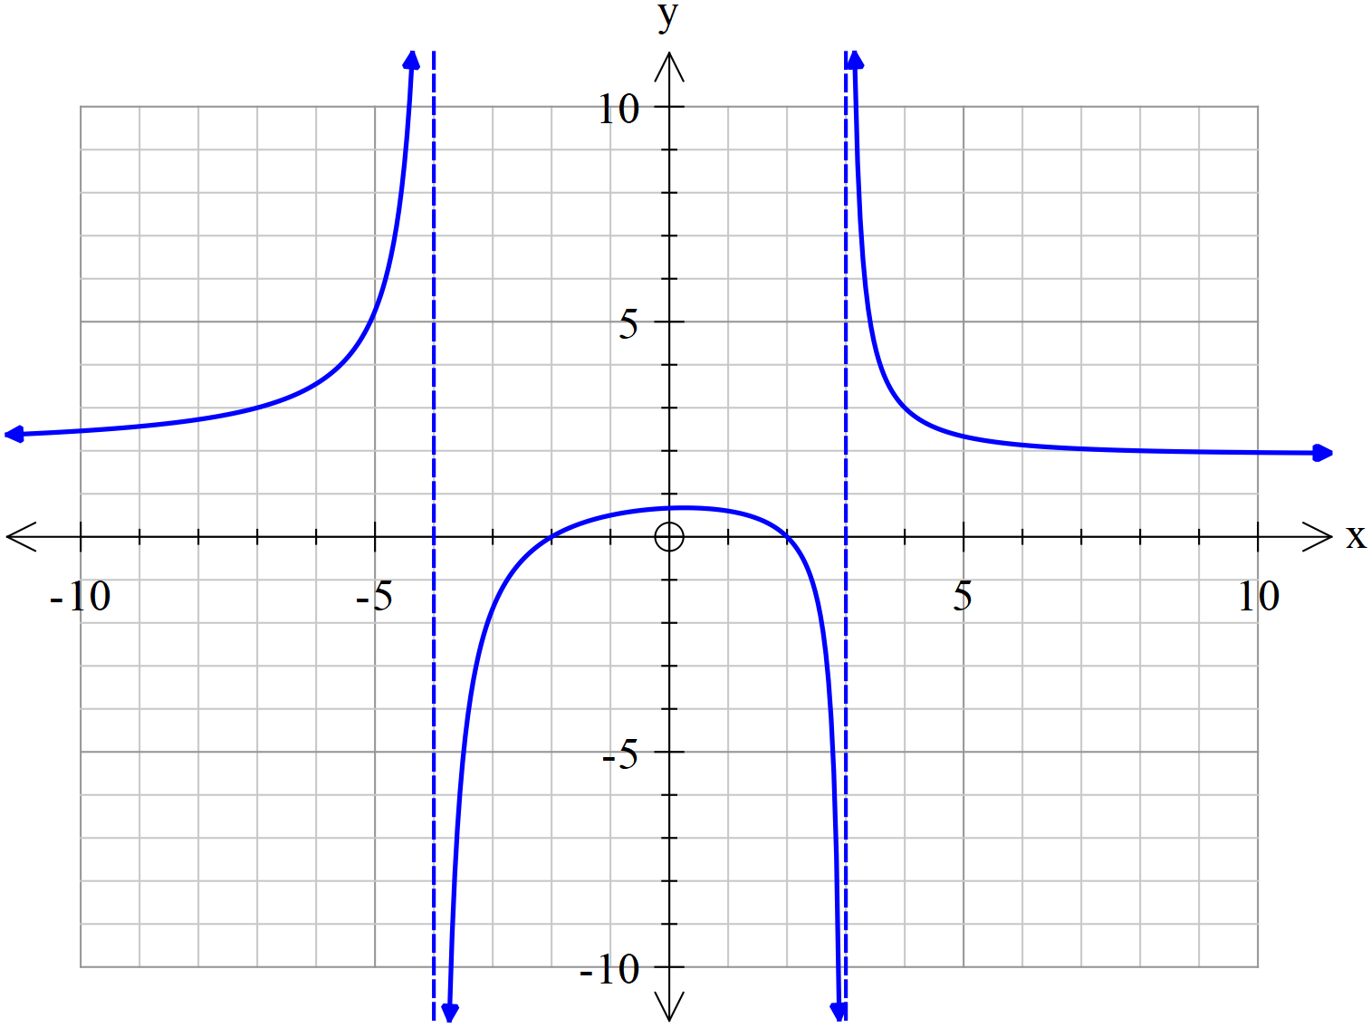

Specific behaviours
vertical asymptotes at x =-4 & 3
horizontal asymptote ay y=2
y intercept near y=2/3
x intercepts at x=-2,2
correct shape between vertical asymptotes
correct shape outside asymptotes

Question 7 (5 marks)
A triangular prism OACB is shown below with O as the origin and points A, B & C have respective position vectors Point P lies on the line in the ratio .

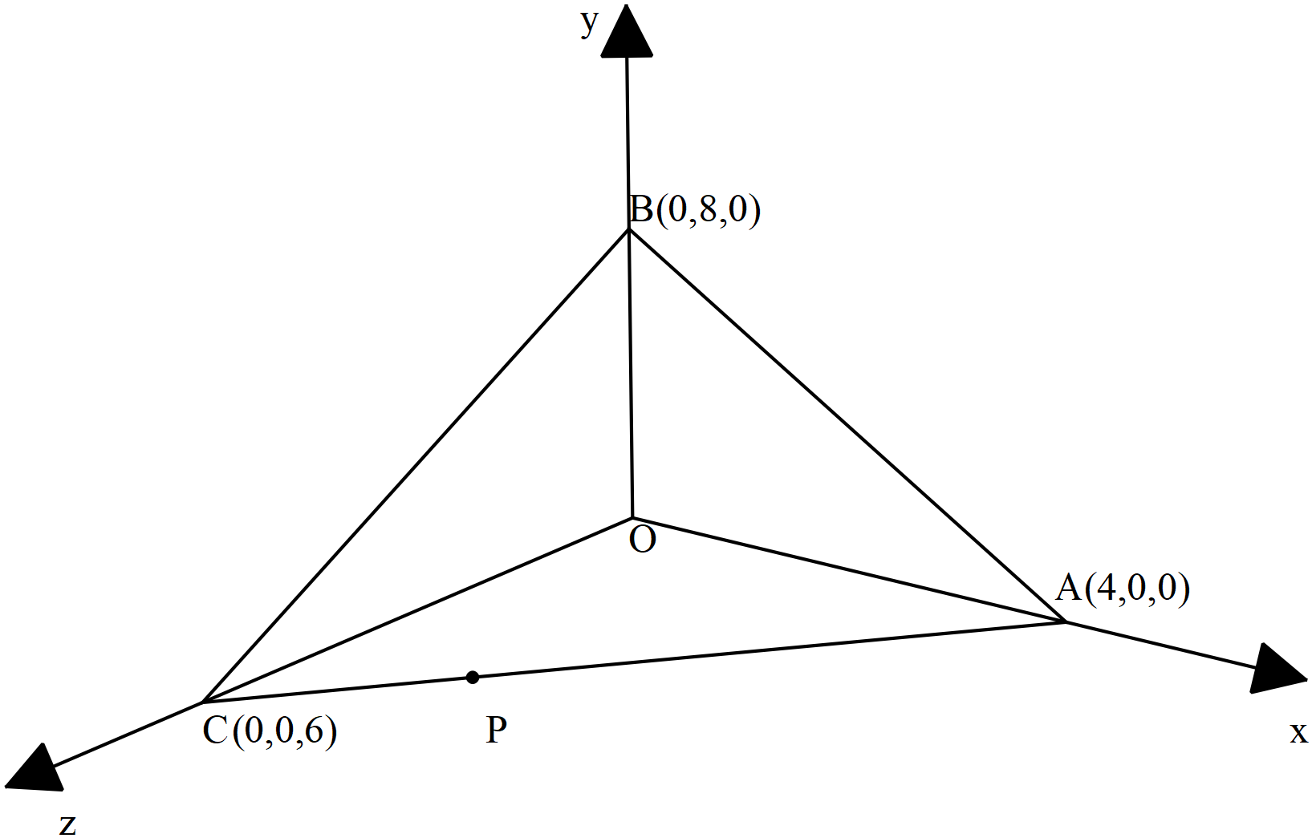
(a) Determine the vector equation of the line that passes through points
( 2 marks)

Solution
Specific behaviours
determines point P
Determines vector equation of line

(b) Determine the cartesian equation of the plane that contains points .
( 3 marks)
Solution
Specific behaviours
determines two vectors in plane
uses cross product to obtain normal vector
determines cartesian equation from vector equation of plane

Question 8 (5 marks)

Consider a circle in the complex plane where the centre is given by and a radius of 5 units. Let be a point on this circle where with and

(a) Determine in exact cartesian form . ( 3 marks)

Solution
Specific behaviours
uses y=3x for point P
subs y=3x into cartesian equation of circle
identifies 3+9i as only solution for P

(b) Sketch this circle and point P in the complex plane below showing all major features.
( 2 marks)
Solution

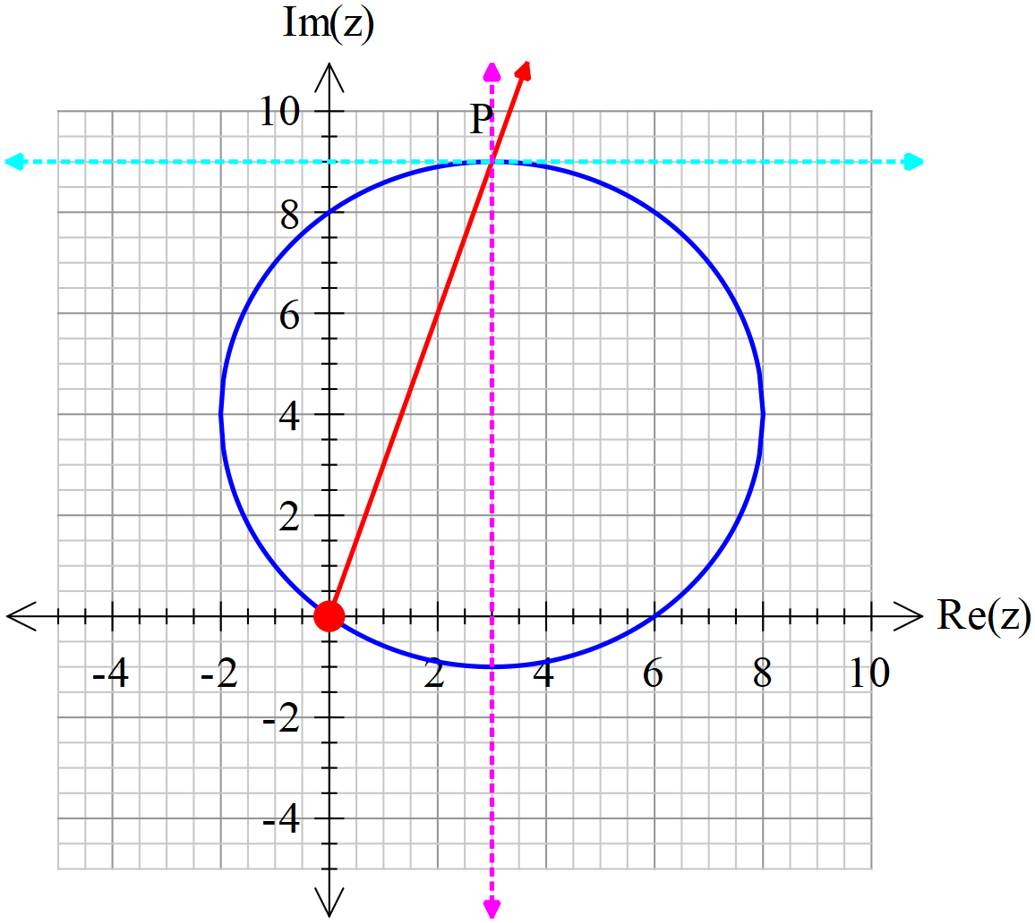

Specific behaviours
sketches circle with correct centre and radius going through (0,0)
shows point P to be on circle at (3,9)

Additional working space
Question number:

Additional working space
Question number:

Additional working space
Question number:

Additional working space
Question number:

Additional working space
Question number:

Acknowledgements

